**Socialist Realism in China**

Socialist Realism was the primary aesthetic doctrine promoted during the 1950s by the People’s Republic of China’s (PRC) Ministry of Culture and the Propaganda Department of the Chinese Communist Party (CCP). Adopted from Soviet theory, the principles of Socialist Realism in the PRC closely corresponded to those proclaimed under the same banner in the USSR and Eastern Europe. As elsewhere, the scope of Socialist Realism extended well beyond its origins in literature and painting. It represented an overarching discourse relating cultural production to Marxism-Leninism, particularly in the way the latter was instantiated in the Soviet Union under Stalin. That said, the PRC’s assimilation of Socialist Realism was distinguished by the way Chinese cultural officials and artists confronted two essential, yet contradictory, aspects of the doctrine: its commitment to Socialist construction and Internationalism, and its appeal to a concept of ‘national form’.

Introduced in China as early as 1933 by literary theorist Zhou Yang (周扬) (1908-1989), Socialist Realism gained prominence in the People’s Republic after Zhou, in his new capacity as Vice-Minister of Culture, endorsed it in a series of official statements made between 1951 and 1953. The term was even inserted subsequently into new editions of Mao Zedong’s ‘Talks at the Yan’an Forum on Literature and Art’, replacing Mao’s original invocation of ‘proletarian realism’. As with contemporaneous initiatives in industry, agriculture and science, promotion of Socialist Realism coincided with the party-state’s call to assimilate the experience of more technologically advanced Socialist countries—particularly, the Soviet Union—in order to hasten the PRC’s development and accelerate its timeline for overtaking and surpassing the achievements of capitalist nations.

One of the clearest instances of this emerged in the medium of oil painting. In 1952, PRC art academies began actively to promote Soviet art, art theory and art pedagogy as models for Chinese practitioners. From 1953 to 1962, such efforts expanded to entail sending Chinese artists to study at the Repin Art Academy in Leningrad and hosting Soviet and East European artists as instructors in the PRC. The first and most influential of these was Soviet oil painter Konstantin M. Maksimov (1913-1993), who taught a class of more than twenty students in Beijing from 1955 to 1957. Soviet-trained Chinese artists became prominent in the PRC cultural establishment. Upon completing their studies, many occupied important administrative and teaching posts throughout the country and they participated actively in the state-sponsored history painting campaigns of 1958, 1961 and 1964. Chief among these artists was Luo Gongliu (罗工柳) (1916-2004), who spent three years in Leningrad from 1955 to 1958. Following his return to Beijing, Luo headed a prestigious oil painting studio at the Central Academy of Fine Arts and taught a second specialized course in Soviet-style painting from 1961 to 1963.

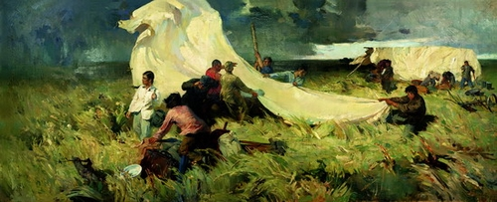

Zhan Jianjun 詹建俊, *Starting Out* 起家, 1957, oil on canvas, 140cm x 348cm, collection of the China Academy of Fine Arts, Beijing . Graduation piece by a student in Maksimov’s oil painting class.

As a result of such efforts, an eclectic combination of nineteenth-century European painting and drawing traditions, processed through the filter of Russian taste and modified according to the needs of Socialist state power, became a vital part of the basic training for oil painters in the PRC. Simultaneously, however, the putative universality of Socialist Realism as a doctrine for Marxist-Leninist art stood in growing tension with an equally strong ideological demand for forms of cultural production more coterminous with the nation’s own heritage. This demand, articulated in calls for art that displayed ‘national characteristics’ and appeared ‘national in form’, had in fact been central to Mao Zedong’s own political and aesthetic views and to Soviet Socialist Realism as originally conceived in the 1930s. Additionally, increasing estrangement between Chinese and Soviet leaders, beginning with the latter’s denouncement of Stalinism in 1956, contributed a pressing geopolitical dimension to the perceived need for promoting endogenous art practices.

The volatile development of ink painting during the 1950s staged this conflicted aspect of Socialist Realism in an exemplary way. After the establishment of the People’s Republic, the powerful cadres placed in charge of reforming China’s art academies viewed traditional Chinese painting as a moribund remnant of the old social order. It and its practitioners were programmatically marginalized as pedagogy structured around oil painting assumed priority. Cultural authorities enjoined ink painters to transform their practice by turning to contemporary subjects, creating imagery that extolled the progressiveness of socialist society and adopting techniques of composition, perspective, modeling and foreshortening derived from European art. Soviet-style drawing instruction became part of the mandatory curriculum for ink painting students, and recalcitrant artists, often older practitioners, found themselves subject to criticism, ostracism and dismissal.

During the time of the Hundred Flowers Campaign (1956), however, appreciation for Chinese ink painting as a valuable national tradition resurfaced with vocal support from high-ranking officials, including Zhou Yang, Premier Zhou Enlai and Mao Zedong himself. Following the initial phase of the subsequent Anti-Rightist Movement (1957-59), Party authorities again rehabilitated ink painting, this time with even firmer institutional sponsorship. Notably, they re-christened the medium *guohua* (国画), or national painting, and examples of reformed approaches to its practice achieved parity with respect to oil painting in the official history painting campaigns of the late-1950s and early-1960s.

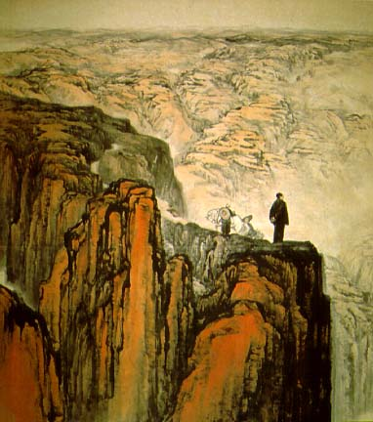

Shi Lu 石鲁, *Fighting in Northern Shaanxi* 转战陕北, 1959, Chinese ink on paper, 218cm x 208cm, collection of the China National Museum, Beijing. Example of ‘socialist realist’ *guohua*.

While the centrality of Socialist Realism eroded in the more inclusive climate of the Hundred Flowers Campaign, PRC cultural authorities, unlike their counterparts in the Soviet Union, did not finally repudiate the doctrine. Zhou Yang’s synoptic 1960 report to the Third National Conference of Chinese Literary and Art Workers included a forceful defense of Socialist Realism, even while simultaneously reaffirming a shift—already underway since 1958—towards the alternative formulation ‘integrating revolutionary realism and revolutionary romanticism’. The rhetorical eclipse of Socialist Realism during the Great Leap Forward (1958-61) crucially highlights the fact that the doctrine, with its Soviet-inspired emphasis on developmentalism, represented only one aspect of Maoist ideological practice. Subsequent PRC aesthetic discourse would increasingly emphasize other theoretical concepts, particularly Mao’s notion of class struggle. Nevertheless, while the period of its explicit promulgation was brief, pedagogical methods and iconography promoted in the name of Socialist Realism would have an enduring impact on PRC art throughout the Mao era and beyond.

**Bibliography and Suggestions for Further Reading**

Andrews, Julia F. (1994) *Painters and Politics in the People’s Republic of China, 1949-1979*, Berkeley: University of California Press. (Chapters 2 through 5)

Top of Form

Clark, John. (1991) ‘Realism in Revolutionary Chinese Painting’, *Journal of the Oriental Society of Australia*, vol. 22/23, no. 1: 1-30.

Bottom of Form

Laing, Ellen Johnston. (1988) *The Winking Owl: Art in the People’s Republic of China*, Berkeley: University of California Press. (Chapters 2 and 3)

Yang, Lan. (1996) ‘“Socialist Realism” versus “Revolutionary Realism plus Revolutionary Romanticism”’. In: Hilary Chung, ed., *In the Party Spirit: Socialist Realism and Literary Practice in the Soviet Union, East Germany and China*, Amsterdam: Rodopi: 88-105.

Zhang, Xudong. (1997) ‘The Power of Rewriting: Postrevolutionary Discourse on Chinese Socialist Realism’. In Thomas Lahusen and Evgeny Dobrenko, eds., *Socialist Realism without Shores*, Durham: Duke University: 282-309.